**Problema 9.3.1.5**

Pentru următoarea funcţie booleana de trei variabile, data prin intermediul tabelei de valori, scrieţi cele două forme canonice: conjunctivă (FCC) şi disjunctivă (FCD). Simplificaţi funcţia utilizând diagrame Veitch.

f5: B3 → B

|  |  |  |  |
| --- | --- | --- | --- |
| x | y | z | f5 |
| 0 | 0 | 0 | 0 |
| 0 | 0 | 1 | 1 |
| 0 | 1 | 0 | 1 |
| 0 | 1 | 1 | 0 |
| 1 | 0 | 0 | 0 |
| 1 | 0 | 1 | 1 |
| 1 | 1 | 0 | 1 |
| 1 | 1 | 1 | 0 |

**Forma canonica disjunctiva:**

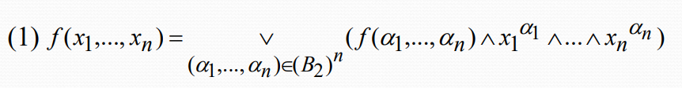

FCD(f5) = f5(0, 0, 0) x0y0z0 ∨ f5(0, 0, 1) x0y0z1 ∨ f5(0, 1, 0) x0y1z0 ∨

f5(0, 1, 1) x0y1z1 ∨ f5(1, 0, 0) x1y0z0 ∨ f5(1, 0, 1) x1y0z1 ∨

f5(1, 1, 0) x1y1z0 ∨ f5(1, 1, 1) x1y1z1

= 0 ∧ x0y0z0 ∨ 1 ∧ x0y0z1 ∨ 1 ∧ x0y1z0 ∨ 0 ∧ x0y1z1 ∨

0 ∧ x1y0z0 ∨ 1 ∧ x1y0z1 ∨ 1 ∧ x1y1z0 ∨ 0 ∧ x1y1z1

= x0y0z1 ∨ x0y1z0 ∨ x1y0z1 ∨ x1y1z0

= ∨ ∨ ∨

|  |  |  |  |
| --- | --- | --- | --- |
| x | y | z | f5 |
| 0 | 0 | 0 | 0 |
| 0 | 0 | 1 | 1 |
| 0 | 1 | 0 | 1 |
| 0 | 1 | 1 | 0 |
| 1 | 0 | 0 | 0 |
| 1 | 0 | 1 | 1 |
| 1 | 1 | 0 | 1 |
| 1 | 1 | 1 | 0 |

**Forma canonica conjunctiva:**

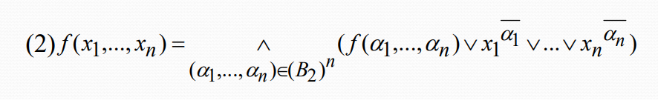

FCC(f5) = (f5(0, 0, 0) ∨ x0 ∨ y0 ∨ z0) ∧ (f5(0, 0, 1) ∨ x0 ∨ y0 ∨ z1) ∧

(f5(0, 1, 0) ∨ x0 ∨ y1 ∨ z0) ∧ (f5(0, 1, 1) ∨ x0 ∨ y1 ∨ z1) ∧

(f5(1, 0, 0) ∨ x1 ∨ y0 ∨ z0) ∧ (f5(1, 0, 1) ∨ x1 ∨ y0 ∨ z1) ∧

(f5(1, 1, 0) ∨ x1 ∨ y1 ∨ z0) ∧ (f5(1, 1, 1) ∨ x1 ∨ y1 ∨ z1)

= (0 ∨ x1 ∨ y1 ∨ z1) ∧ (1 ∨ x1 ∨ y1 ∨ z0) ∧ (1 ∨ x1 ∨ y0 ∨ z1) ∧

(0 ∨ x1 ∨ y0 ∨ z0) ∧ (0 ∨ x0 ∨ y1 ∨ z1) ∧ (1 ∨ x0 ∨ y1 ∨ z0) ∧

(1 ∨ x0 ∨ y0 ∨ z1) ∧ (0 ∨ x0 ∨ y0 ∨ z0)

= (x1 ∨ y1 ∨ z1) ∧ (x1 ∨ y0 ∨ z0) ∧ (x0 ∨ y1 ∨ z1) ∧ (x0 ∨ y0 ∨ z0)

= s

Simplificaţi funcţia utilizând diagrame Veitch.

|  |  |  |  |  |
| --- | --- | --- | --- | --- |
|  |  | |  | |
|  |  | m6 | m2 |  |
|  | m5 |  |  | m1 |
|  |  |  | |  |

FCD(f5) = ∨ ∨ ∨

max1 = m6 ∨ m2 =

max2 = m5 ∨ m1 =

M(f5) = {max1, max2}

M(f5) = C(f5)

Cazul intai al algoritmului de simplificare => avem o singura forma simplificata a functiei:

f5S(x, y, z) =